 | Central Water Commission  KRISHNA GODAVARI BASIN ORGANISATION  LOWER GODAVARI DIVISION | 303, Krishna Godavari Bhawan  11-4-648, A.C.Guards  Hyderabad-500004  Ph:040-29808752
Daily Flood Situation Report cum Advisories
29.06.2019
- Rainfall Situation
Chief Amount of rainfall recorded at 0830 hours IST of today (5 cm or more) as per IMD
Name of Place (State) | Rainfall (in cm)
Korpana(MS) | 13
Bejjur(TS) | 10
Sarangapur(TS),Bazarhathnoor(TS),Joiti(MS), | 7
Khandahar(MS),Khanpur(TS),Wankdi(TS),Balharsha(MS),Ghugus(MS),Saoli(MS),Mulchera(MS),  Dilawarpur(TS), | 6
Armur(TS), KAMMAR PALLE(TS),Mortad(TS),Nandipet(TS),Navipet(TS),Manthani(TS), Bhoopalapalli(TS),Ballarpur(TS),Chandrapur(MS),Narayanpur(TS),Koraput(Odisha),  Umarkote(Odisha) | 5
  - Rainfall forecast for next 2 days issued on 29thJune 2019 (Midday) by IMD

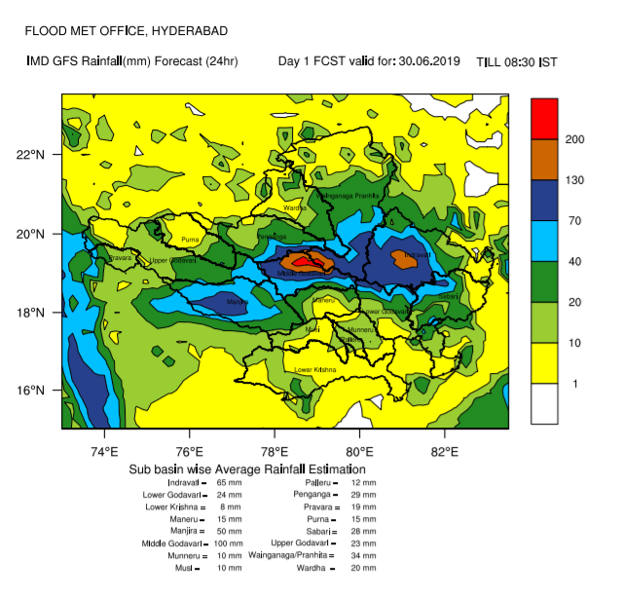
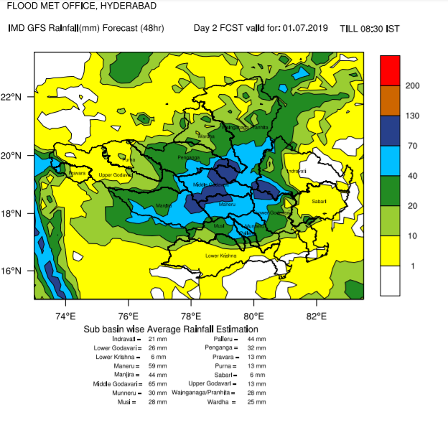
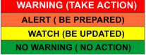
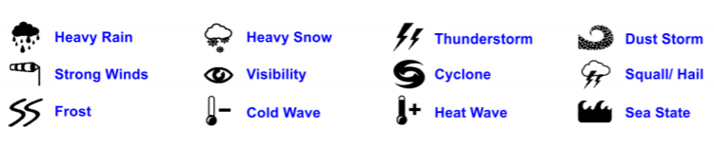
In theSub Basin of Indravati on Day1 and in the Sub Basin of Middle Godavari on Day1 and Day2 heavy Rainfall warning is predicted.In other SubBasins of Godavari moderate rainfall is expected. So keep watch on all the sites of Godavari Basin.

